SET 14 – SURVEY RESULTS ANALYSIS
Aim
To analyze survey results using stacked bar chart, grouped bar chart, and table in R.
Algorithm
- Create the survey results dataset.
- Convert the questions into long format.
- Create a stacked bar chart for Question 1.
- Create a grouped bar chart for all questions.
- Display the survey response data in a table.
R Program
library(ggplot2)
library(tidyr)

survey <- data.frame(
ID=c(1,2,3),
Question1=c("A","B","C"),
Question2=c("B","A","A"),
Question3=c("C","D","B")
)

long <- pivot_longer(survey, -ID,
names_to="Question", values_to="Answer")

ggplot(long[long$Question=="Question1",],
aes(Answer, fill=Answer)) +
geom_bar() +
labs(title="Question 1 Survey Results",
x="Answer", y="Count")

ggplot(long, aes(Question, fill=Answer)) +
geom_bar(position="dodge") +
labs(title="Overall Survey Results",
x="Question", y="Count")

print(survey)
OUTPUT:
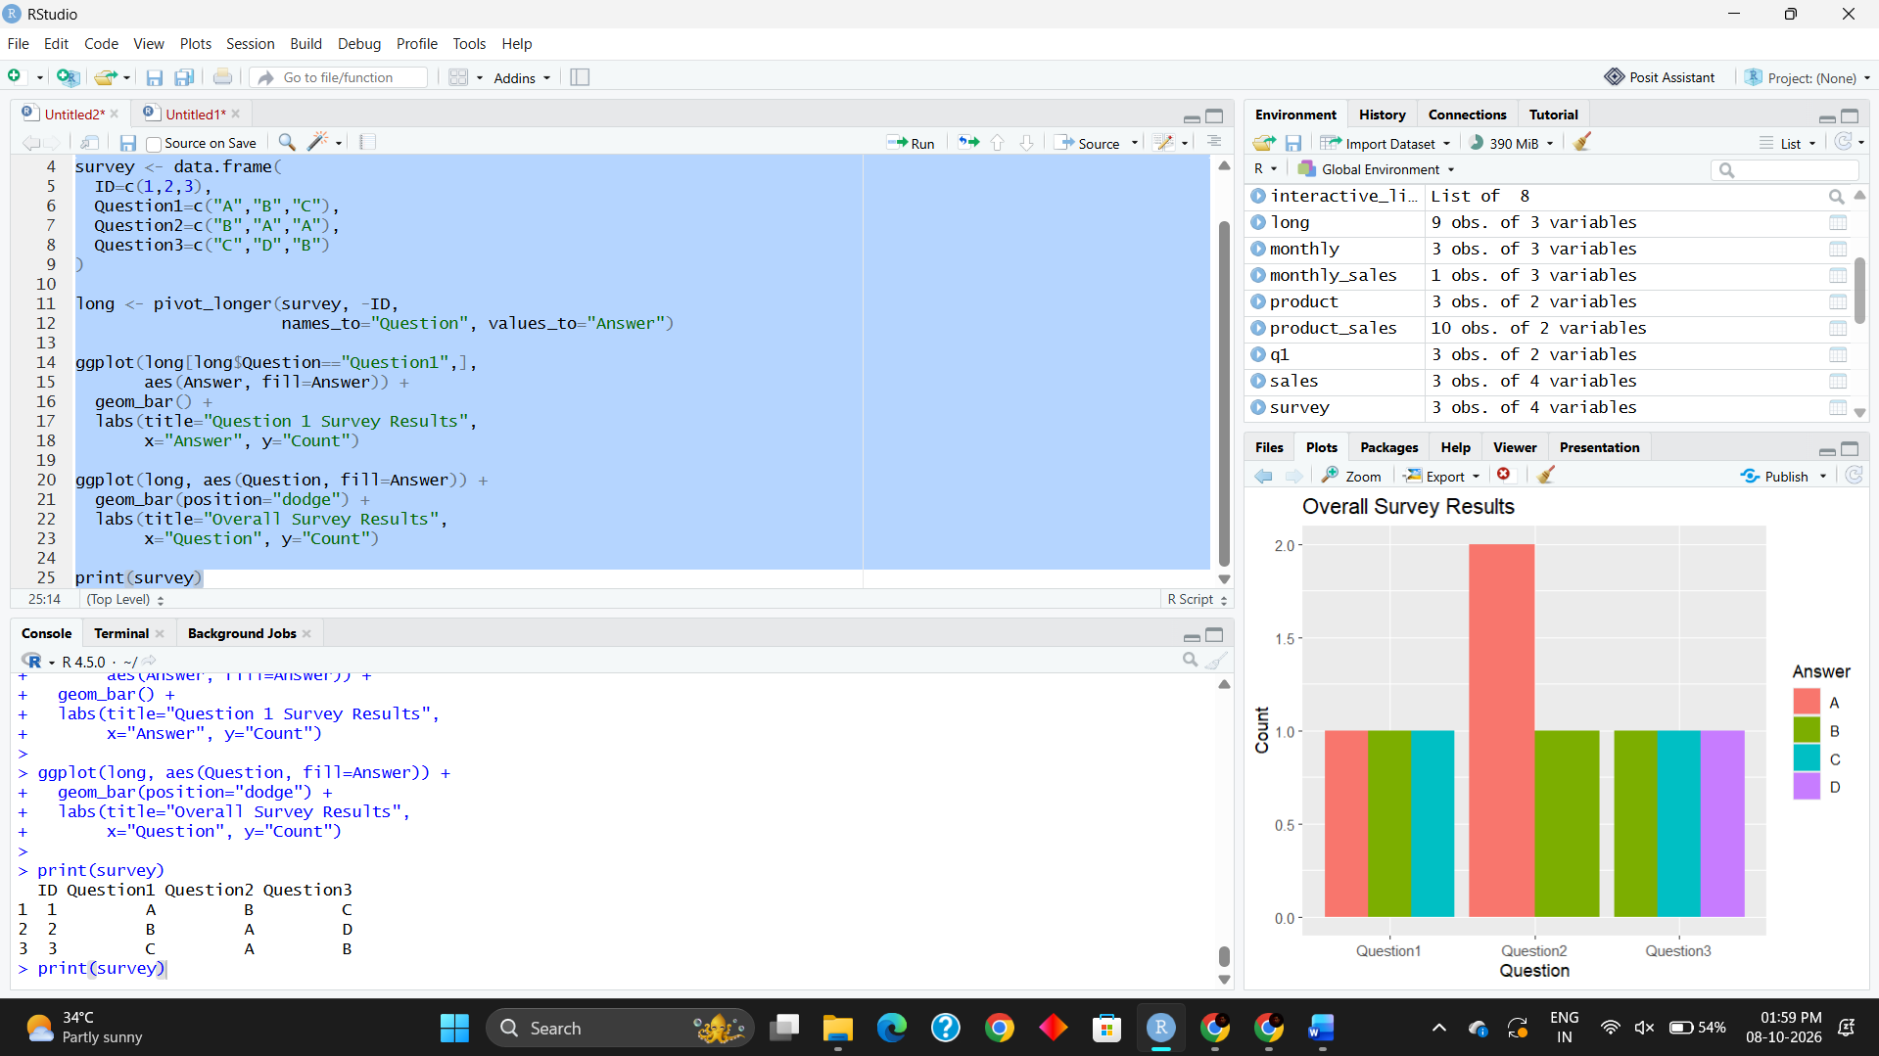
Result
The stacked/grouped charts successfully display the distribution of survey responses for the questions. The table presents the survey response data for each respondent.

